**Contents**

**Week 10**

1. **My learning**

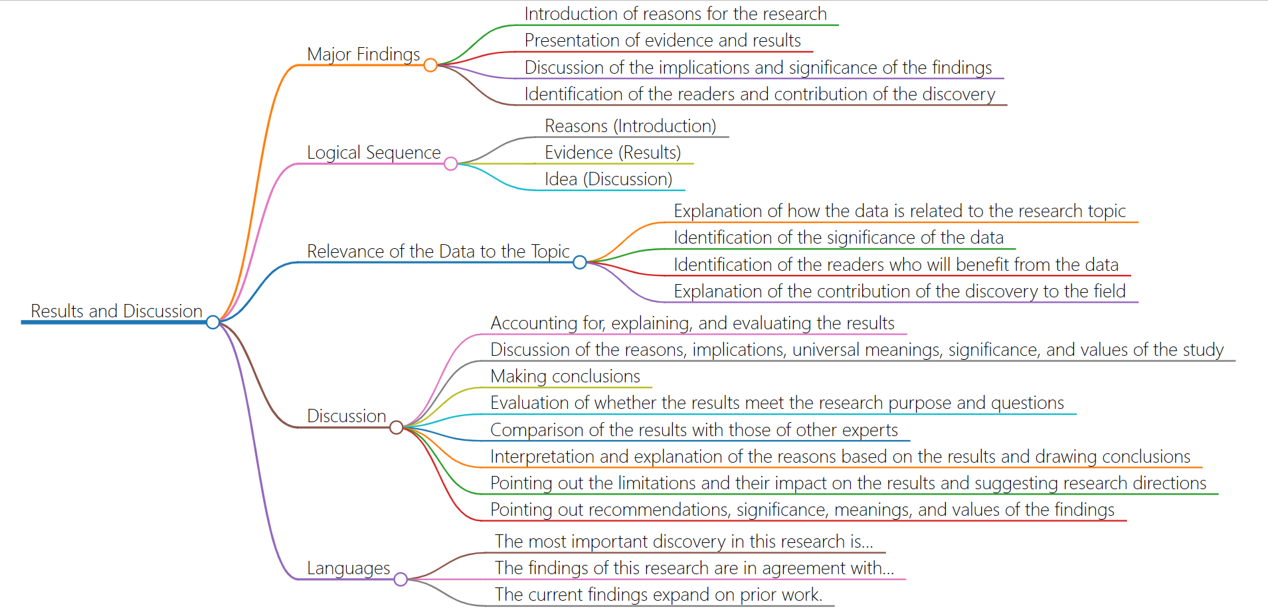

1. **Learning outcomes**

* Understand the logical sequence of research results and discussion.When writing a paper, you can organize your findings and discussions in a logical order.
* Understand the relationship between data and the research topic as well as the significance and contribution of data.When analyzing data, it is necessary to consider the relationship between the data and the research topic as well as the significance and contribution of the data.
* The content and structure of the discussion were studied, including interpretation, evaluation and comparison of the results, as well as answers and suggestions for research objectives and questions.When discussing the findings, the results need to be interpreted, evaluated and compared, and recommendations and directions for future research need to be made.
* I learned the way of language expression in academic papers.When writing academic papers, we can learn from some common language expressions to improve the expression ability and quality of papers.

1. **My behavior and attitude**

My learning attitude this week was a little loose. I didn't think about the presentation of one-minute content seriously, so that others could quickly understand my introduction

**4．Improvement**

I should have thought more carefully about how to present my introduction better, so that others could understand my content more quickly and suggest improvements. At the same time, it is also necessary to adopt different presentation methods at different time, so as to better adapt to different occasions and audiences